# 2fIwIuG2CDUDKqBMpacFSftxc8AZdBaHc7x67G1_fQYqd7ov_8h4nOKO7r1Zw9fXHaxf9vDMsP0CADVDFYbpM0KtEblcgOu9Ab7GjssNtx6YQXve2d_CgaM8UVvrQBt0Og1tt6lr.jpg

**SecurityBuddy**

**Date:** 05.09.2019

**Submitted To:**  
Intisar Tahmid Naheen

Lecturer,Dept of ECE

North South University

**Submitted By: (Group -3)**

|  |  |
| --- | --- |
| Shafin T. Mashfu | 1620255042 |
| Rubayet Zaman | 1620684642 |

# Abstract:

Accidents don’t come announced. It just happens. Everyday lives are lost due to man-made disasters. But these disasters are gruesome within the cities. Fire related accidents are very common throughout the world. According to the World Fire Statistics report from 2017, there were 1.9 fire deaths per 100 thousand inhabitants in 2015 [World Fire Statistics 2017]. The data is collected from the fire statistics of 31 countries which represent 14% of world’s population.Quite often these fires are ignited from the polymeric materials we use in our daily life. As a result, developing countries like Bangladesh are at high risk as the frequency of fire-related accidents increase with time.

In such cases, fire services are dispatched but they are unaware of the number of lives in danger. They must rely solely on their firm intuition.

Our objective is to implement a real-time interlinked hardware and software system designed for such emergency cases, where the first responders will be aware of the exact number of lives at stake.

In short:  
1) this project will help the first responders to know the exact number of people in the vicinity

2)this device can also be installed in megamalls, offices, hospitals to keep count of people.

3)A notification system is used to let the concern know about the number of people easily.

# Introduction

Our goal is to count each and every people that get into the building and never miss out a people to count. For this, a live feed gets broadcast via raspberry pi camera and that the live feed gets processed using SSD (single shot detection algorithm). To remove the noises in the background, gaussian blur and background subtraction are used. Contouring is used for the tracking box which will track the people. Email Notification system is integrated using smtp library.

# Background & Research:

### 1)Raspberry Pi:

### A Raspberry Pi is a credit card-sized computer.It is designed mainly for education purpose. It is an inexpensive and affordable device that can be used to improve basic programming skills and hardware understanding at the university level. It is small in size. The Raspberry Pi is slower than a modern laptop or desktop but is still a complete Linux computer and can provide all the expected abilities that implies, at a low-power consumption level. it comes with a camera which is called Pi camera module.

### The pi has a camera module that can be used to take high-definition video, as well as still pictures. It's able to deliver clear 5MP (2560×1960 pixels) resolution image, or 720p HD video recording. It is very small size (The board itself is tiny at around 25mmx 20mmx9mm & weighs just over 3g). It’s easy to use with raspberry pi.

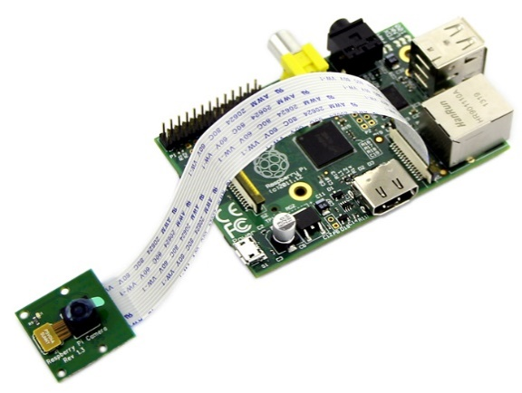

### 2)Gaussian Blurring:

In order to process the image collected through the live feed, the image is convolved with gaussian kernel which is a low pass filter that removes high frequency components from the image. In gaussian kernel width and height (both should be positive and odd) along with standard deviation in X & Y direction are taken into consideration. It is used to remove noise from the image.

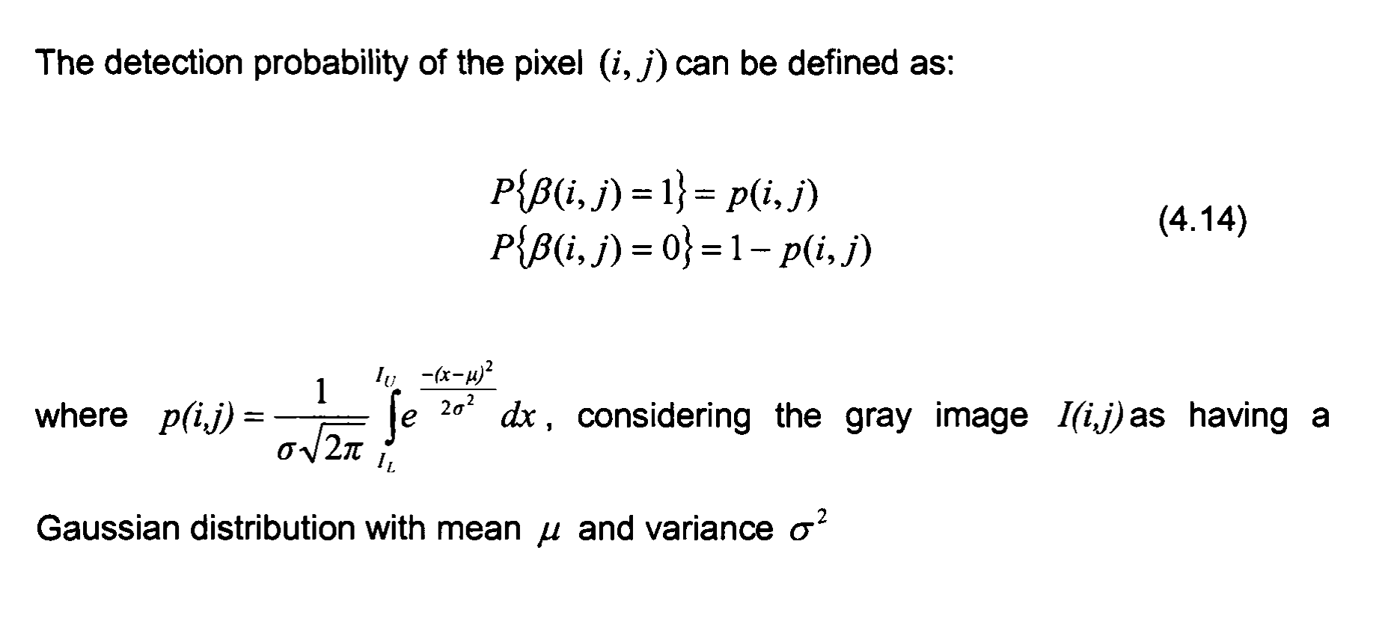

### 3) Background Subtraction:

While processing an image one needs to differentiate the moving foreground object from the static background. Here background subtraction comes into play. In background subtraction, the algorithm used to process the image is the combination of per-pixel Bayesian segmentation & statistical background image estimation. It detects moving foreground using Bayesian interface. As shadows are moving object too but can not be present in the processing result, morphological filtering operations like closing and opening are introduced to remove the edges and noises.

### 4)Contour:

Using contours in OpenCV, one can get the shape of the object and track it according to its shape. It is substantial for shape analysis. We used bounding box for detecting the objects. For a bounding box, instead of taking all the points around the box, it takes four points to make a bounding box and that is how it saves memory. threshold and canny edges are taken into consideration before drawing contours around the objects. It serves better accuracy.



### 5)Centroid Tracking:

It is used to detect the object and tracking it throughout the frame. Initially the object is framed by a bounding box. The bounding box has coordinates of X & Y. Each bounding box gets assigned an ID based on the centroid (centre of the X & Y coordinates) of the bounding box.

Here, Euclidian distance algorithm is used to keep the track of the object. The Euclidian distance between two subsequent frames will be less than all the other distances between them. Then the object gets registered with a unique ID. The object gets deregistered when it leaves the field of view.

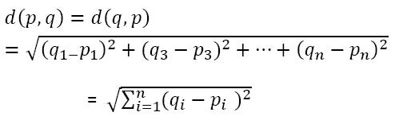

Fig: Euclidian distance between two points.

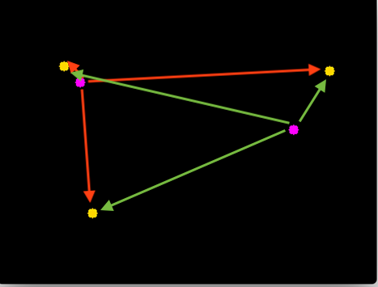

Fig: Visual representation of Euclidian distance between centroids of objects

### 6)SMTP library:

SMTP stands for simple mail transfer protocol. In python, smtplib is used to establish a module of an SMTP client session object that can be used to send mail to any internet associated machine with an SMTP or ESTMP listener daemon. The smtplib is used in the project to notify the concerned about the number of people has entered in the vicinity.

# List of Components:

* Computer
* Raspberry pi 3
* Pi Camera
* Memory Card
* USB Cable
* Power Cable
* HDMI Cable
* Monitor
* Keyboard
* Mouse

# Technology Used:

* Cv2 library- used for image processing
* Numpy library- used for data manipulation and analysis
* Stmplib- used for setting up a client session object to send and receive mail

# Project Costing:

|  |  |
| --- | --- |
| **Name of the Equipment** | **Price(BDT)** |
| Raspberry pi 3 | 3500 |
| Pi Camera | 1650 |
| Raspberry pi cover | 200 |
| SD memory card (8 GB) | 400 |
| HDMI Cable | 400 |
| Power Cable | 200 |
| **Total** | **6350** |

# Project Details:

1)After setting up the Raspberry Pi 3 and integrate it with Pi camera we get the live feed using the ip stream.

2) After that we needed to process the live feed.

2a.We used Gaussian blur to remove noises and edges from the video.

2b.Background Subtraction and addition is used to differentiate dynamic foreground from the background.here,MOG2 is used for subtraction and gaussian blurring as it is faster and process pixel by pixels.

2c.We used morphological filtering to to split shadows to be considered as a moving object.

2d.After that, it comes to tracking the object.We tracked the object using the centroid of the bounding box. We used Euclidian distance to register and deregister an object by assigning a unique ID.

2e.Gaussian blur, Background Subtraction, Morphological Extraction, Centroid Tracking all are done using cv2 and bumpy library.

2f.Lastly, we used a counter to keep track of the object that entered in the building.For that we used smtp library.

# Contributions:

|  |  |  |  |
| --- | --- | --- | --- |
| **Task Name** | **Details** | **Contributor** | **Week No** |
| Setting Up Raspberry Pi 3 | * NOOBS was downloaded in the Raspberry pi * Raspbian OS was installed via NOOBS in Raspberry Pi 3 | Rubayet Zaman | 1 |
| Setting up the camera | * Camera was enabled from Raspbian setting * Camera was turned on to stream live feed using the python script. | Rubayet Zaman | 2 |
| Gaussian Blur | It is implemented to remove the noises and edges from the image. | Shafin T. Mashfu | 3 |
| Background Subtraction and Addition | Background subtraction and addition was used for the segmentation of moving object from static background. | Shafin T. Mashfu | 4 & 5 |
| Morphological Extraction | Removes shadows from the moving object count by applying morphological filtering | Shafin T. Mashfu | 6 & 7 |
| Contour | used in the project to analyze the shape of the object in the bounding box | Rubayet Zaman | 8 & 9 |
| Centroid tracking | It is used for registering the object with a unique ID. | Shafin T. Mashfu | 10 |
| Counting Code | Starts to count the people entering or exiting the building | Shafin T. Mashfu | 11 |
| Smtplib(Email Notification) | Used for sending the mail to the concerned authority with the numeric value of people enter/exit the building | Rubayet Zaman | 12 |

# Future References:

1)<https://docs.opencv.org/3.2.0/db/d5c/tutorial_py_bg_subtraction.html>

2)<https://www.pyimagesearch.com/2018/07/23/simple-object-tracking-with-opencv/>

3)<https://docs.opencv.org/3.1.0/d4/d13/tutorial_py_filtering.html>

4)[freecodecamp.org/news/send-emails-using-code-4fcea9df63f/](http://freecodecamp.org/news/send-emails-using-code-4fcea9df63f/)

5)<https://www.raspberrypi.org/downloads/>